**R Users Group**

**“Intro to R,” or:**

**“How I Learned To Stop Worrying And Love the R”**

**Jacob Steele**

*There are a lot of pages, but it’s just because of all the pictures.

**Background:**

I remember when I was first diving into R and other programming languages as tools—for science or for personal use. Even as someone with a background of tinkering with technology, some of the videos or examples I would see could feel overwhelming: I didn’t understand the language, I couldn’t think of practical applications, and it felt like people had every command memorized and at-the-ready. That sort of thing was discouraging and held me back from utilizing the tools to their greatest potential.

**Why give this talk?:**

I was very excited when I heard that this group was being organized. However, I was afraid that, as helpful as it could be for people, they may not feel similarly uncomfortable/intimidated getting started. I wanted to have this meeting to “bridge the gap” for people, and to ease their minds going in.

**My Background:**

I’m not an expert. My background is in molecular biology and I finished my Bachelor’s in Biology at A-State in 2016. I finally started investigating programming after my degree, in early 2017. Coming from that perspective, I felt like I could be an “audience surrogate” of sorts—I could say, “Hey, I’ve been there. This is how I made it easier.”

**Summary:**

Wanted to give an overview of some key points for getting started with R, bridge the gap for newcomers, and to help everyone become more familiar with it.

Table of Contents

(Ctrl+Click on a section to jump to there in the document!)

RStudio Setup on Your Own Computer 2

Overview: 2

R Setup 2

RStudio setup: 4

Optional Tweaks 8

General tab (on left): 9

Code tab (on left): 10

Appearance tab (on left): 13

Navigating RStudio 14

UL: Script Editor 15

UR: Environment and History. 15

LL: Console, Terminal, Jobs. 16

Console 16

Terminal 17

Jobs 18

LR: Files, Plots, Packages, Help, Viewer. 19

Files 19

Plots 20

Packages 21

Help 22

How to make use of R as a beginner 23

R as a Calculator 23

Next Steps 23

Learning Resources 24

GOOGLE. 24

YouTube 24

Swirl 24

Coursera 24

Textbooks 24

Package Documentation 24

StackExchange/Online Forums/Documentation 24

Conclusions 25

# RStudio Setup on Your Own Computer

## Overview:

RStudio was the way I found to make R more user-friendly for myself. That helped me use the program more and feel more comfortable trying new things in R.

RStudio uses a graphical interface instead of inputting commands into a console, so it is especially nice for those unfamiliar with console/terminal usage. This graphical interface makes it easy to keep track of and preview your variables, write scripts in an orderly environment, and access help when you need it!

In order to setup RStudio on your computer, you must first install R. After installing R, you can proceed to installing RStudio. I will walk through each step here.

## R Setup

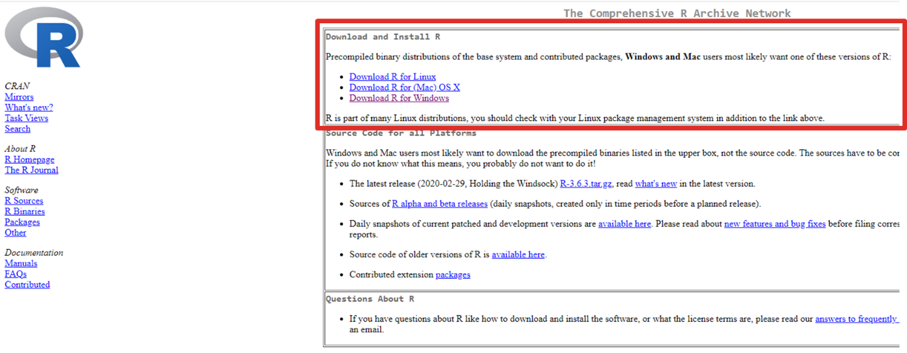

Download R for your machine from <https://cran.rstudio.com>

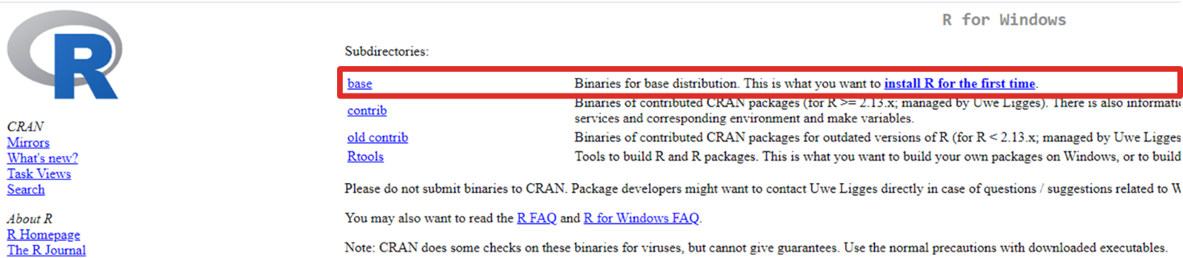

Select “base”

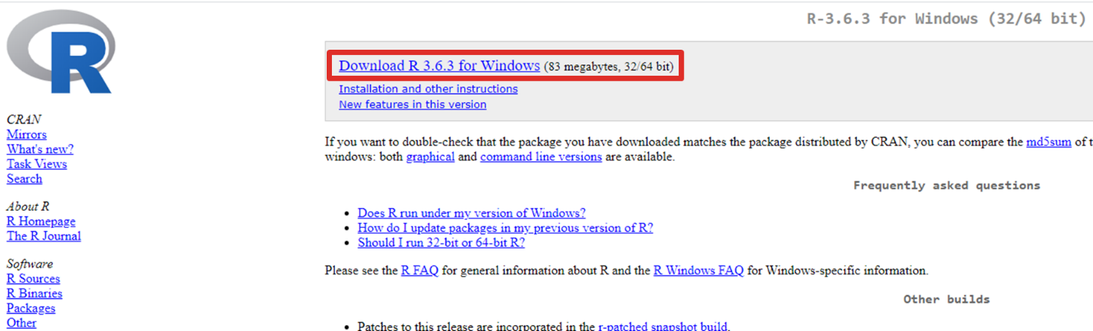

Select “Download”

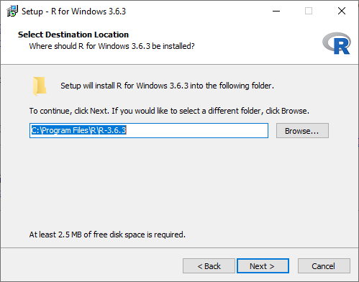

Proceed through the installer. (I suggest no desktop shortcut)

## RStudio setup:

Download RStudio Desktop “Open Source Edition” from <https://rstudio.com/products/rstudio/>

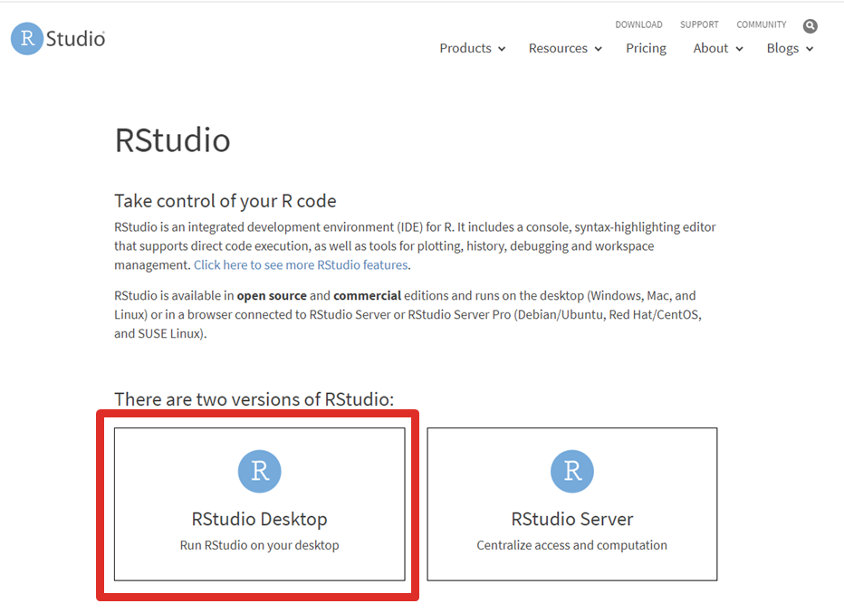

Click “RStudio Desktop”

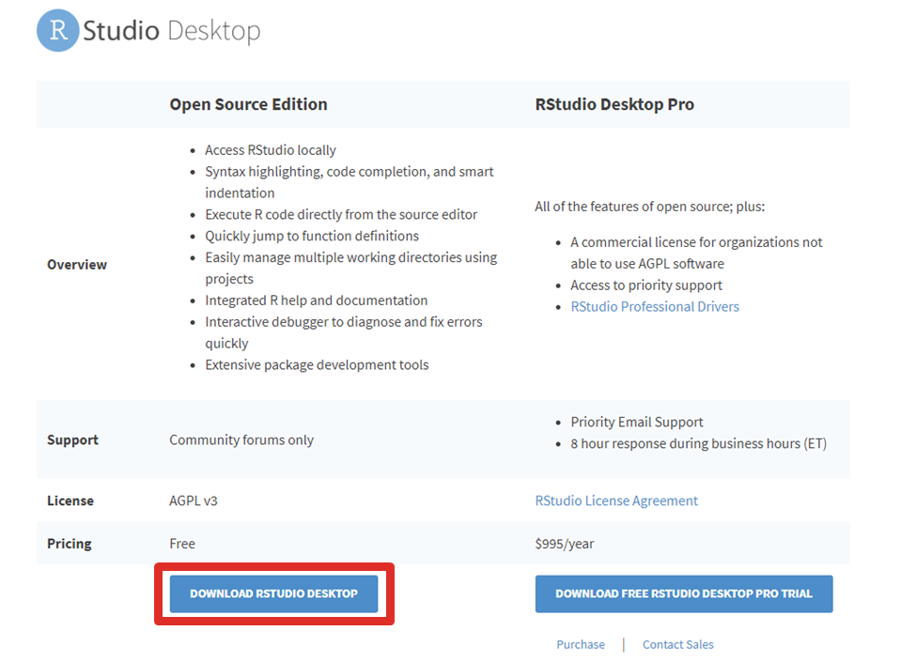

Click “Download RStudio Desktop” in the Open Source Edition column

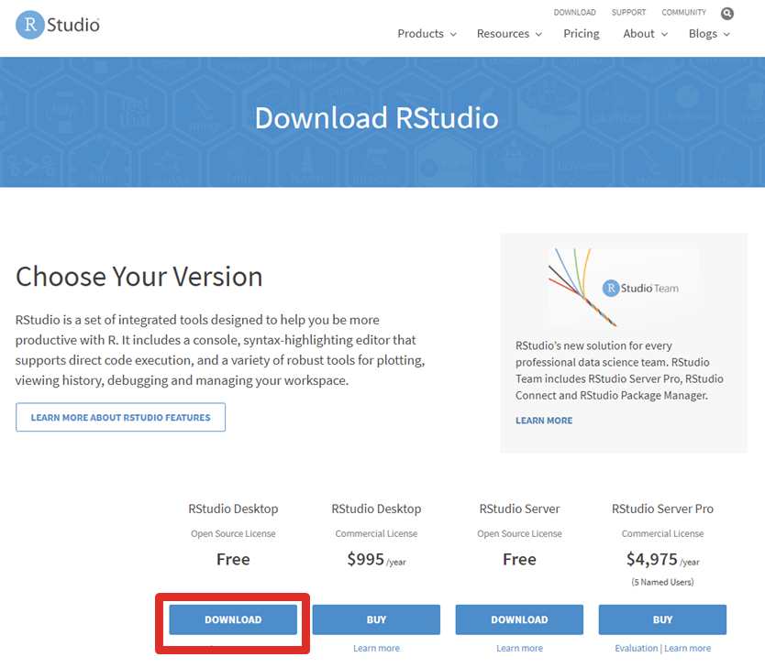

Click the Download button for RStudio Desktop Free

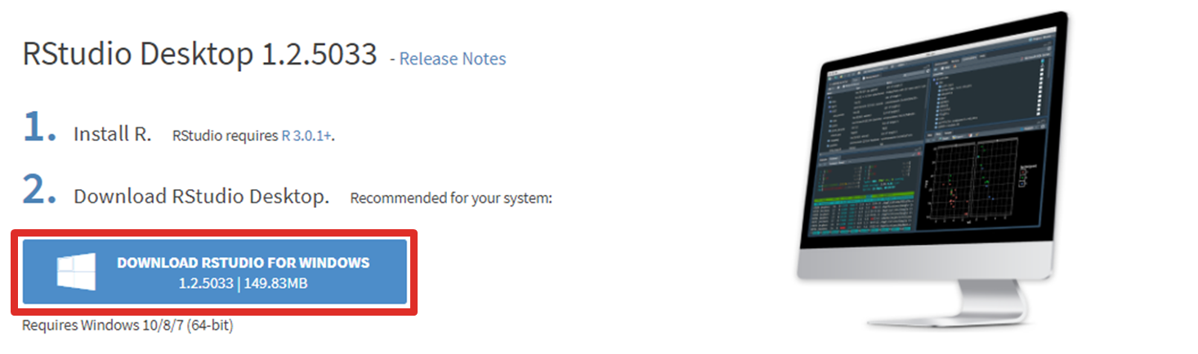

Click the (final) download button

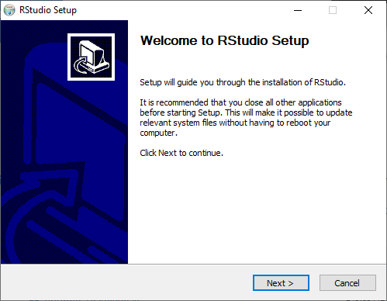

Proceed through the installer. (I suggest that you make a desktop shortcut.)

**Run RStudio, and you’re ready to go!**

# Optional Tweaks

You can get started using RStudio as-is, but there are some tweaks I’ll suggest… All of these changes will be made in the “Global Options” menu in RStudio.

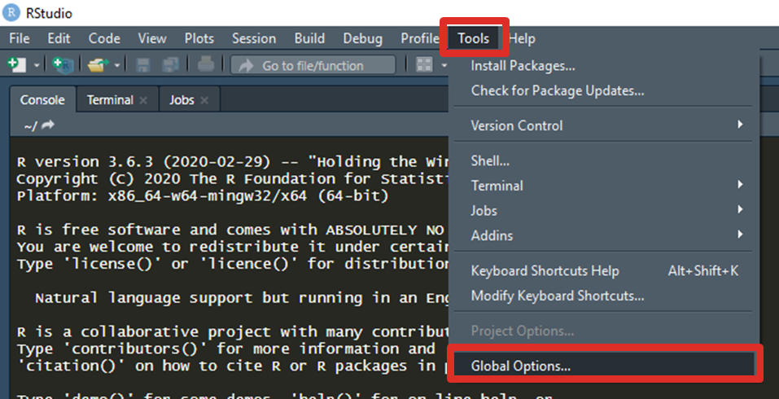Open RStudio, select the Tools drop-down menu at the top, then click “Global Options”

## General tab (on left):

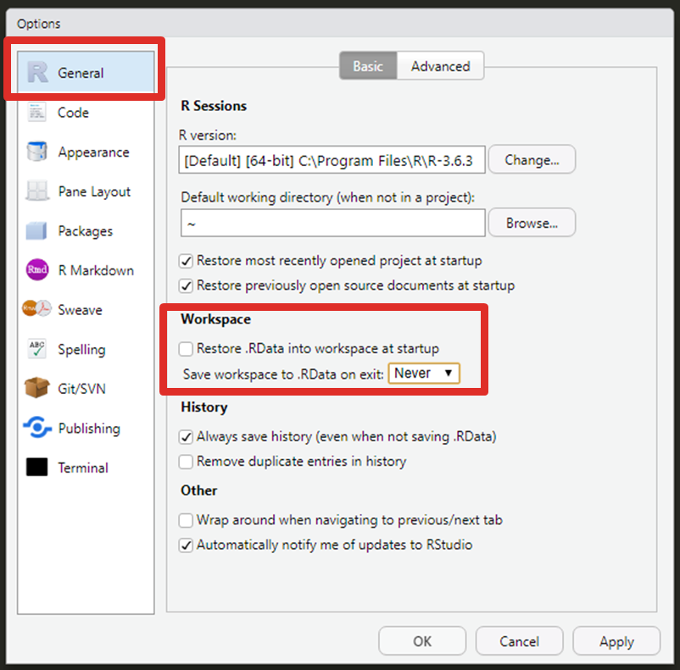

Deselect “Restore .RData into workspace at startup” and change the dropdown for “Save workspace to .RData on exit:” to “Never”

Helps you have a fresh start of sorts when you open RStudio each time

## Code tab (on left):

### Editing Tab (At the top)

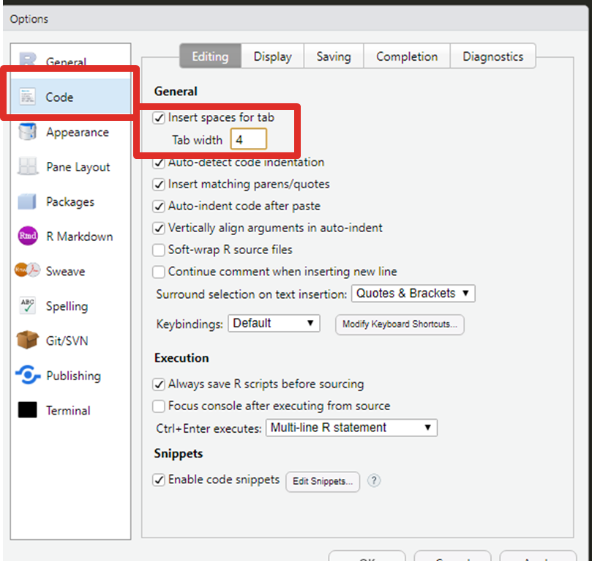

Change “Tab width” to 4

Makes it easier to differentiate between different indentations

### Display Tab (At the Top)

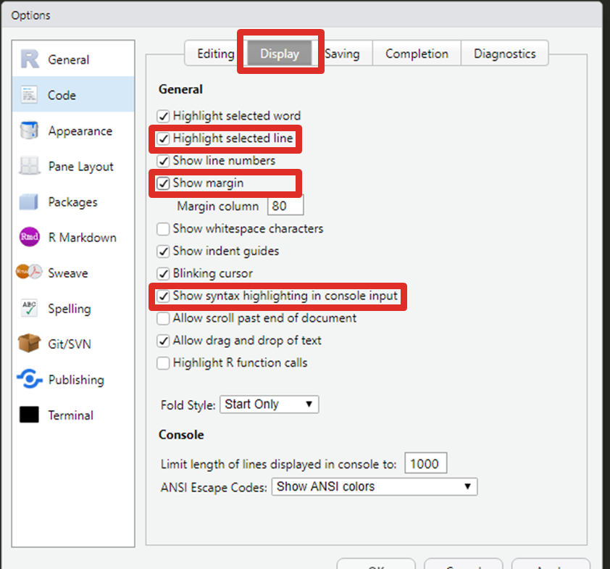

Click the “Display” tab at the top of the Options window. Enable “Highlight selected line,” “Show margin,” and “Show syntax highlighting in console input.”

Make it much easier to read and navigate your code, especially in longer files

### Saving Tab (At the Top)

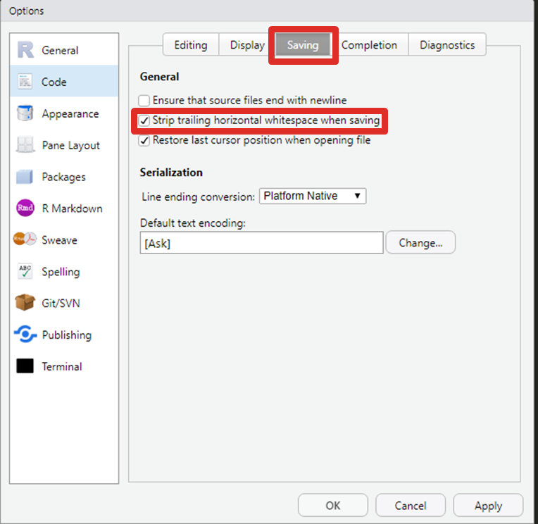

Extra optional: select “Saving” tab at the top. Enable “Strip trailing horizontal whitespace when saving.”

Best practice, though not totally necessary.

## Appearance tab (on left):

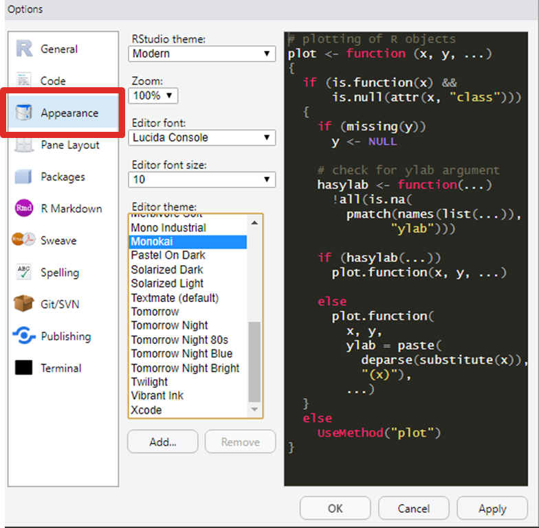

Try different settings in the Appearance tab! Change them to suit your needs. Here, you are able to change the theme, zoom, and font/size, to suit your preferences.

Personal favorite editor themes: **Monokai** and **Tomorrow Night Bright**

# Navigating RStudio

Inside of RStudio, there are typically **four panels**.

*Note:*

*You may only see three panels on first install and be missing the “Upper Left” panel. This is just because you have not opened a script yet!*

*If you would like to see the panel, open the File menu and create a New Script File.*

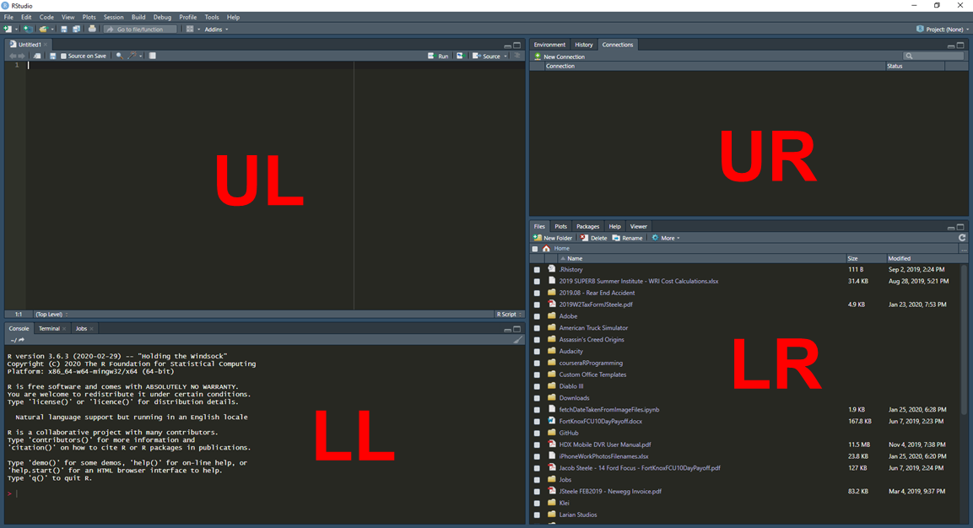Four panels

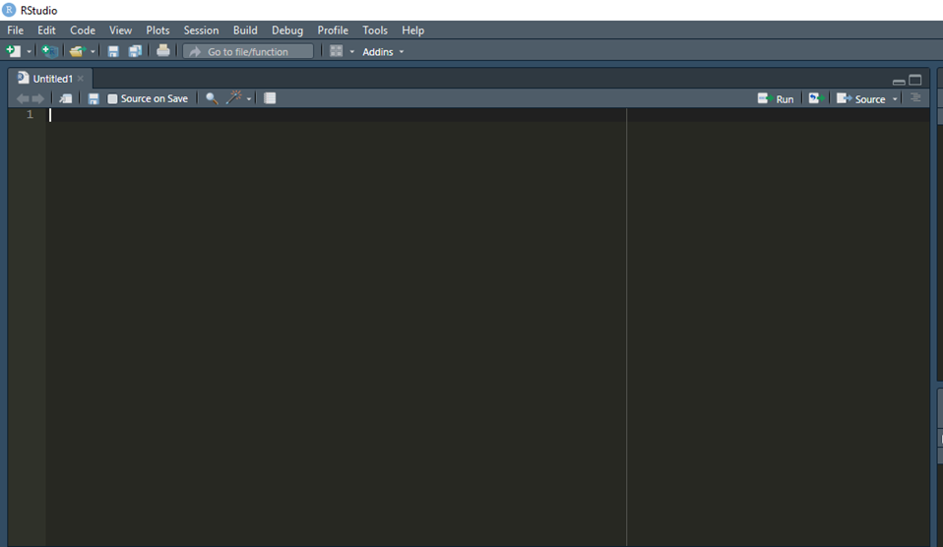

## UL: Script Editor

The Script Editor allows you to write out the scripts you want to run in R. Allows you to make multiple steps happen at once in a repeatable fashion instead of typing out commands one-at-a-time.

## UR: Environment and History.

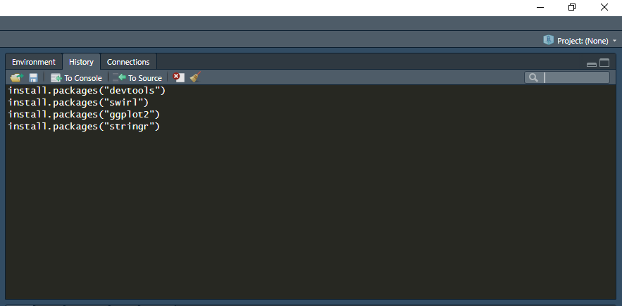Environment shows current variables, etc. If it is something like a table of data, can be opened to view as a new tab in the Script Editor.

History is a list of commands submitted to console.

## LL: Console, Terminal, Jobs.

### Console

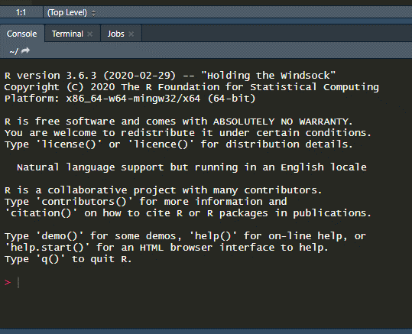This is where R is actually running. Commands can be entered directly here, or sent here from Script Editor. Output and interaction can also take place here.

### Terminal

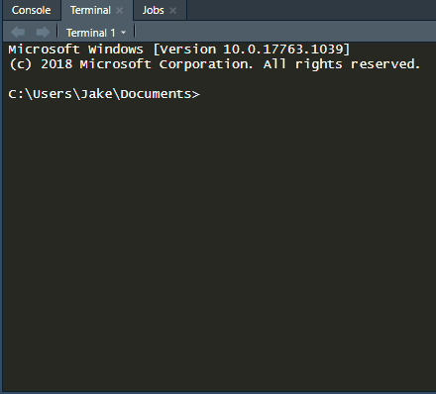The terminal is similar to command prompt/system shell. Too much to cover here, but you shouldn’t have to worry too much about it for now.

### Jobs

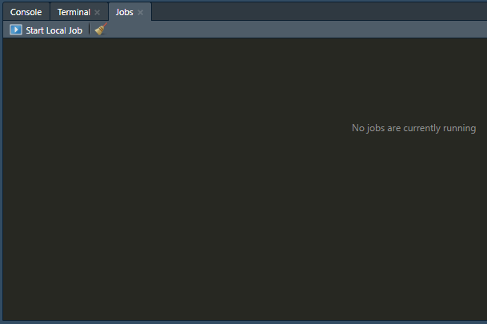

The Jobs tab is relatively new. This tab is similarly “high-level” and used a bit less often starting out. However, when you tell R to run a script, it is sent here. Not much beginner-level interaction should have to take place except for long, complicated scripts. If your script seems to be taking a while, you can check its status on this tab.

<https://blog.rstudio.com/2019/03/14/rstudio-1-2-jobs/>

## LR: Files, Plots, Packages, Help, Viewer.

### Files

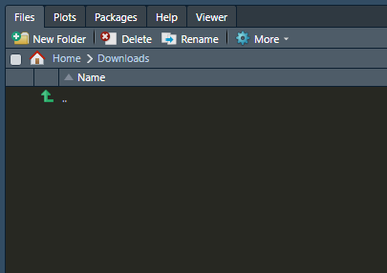This tab acts as a simple file browser, just like opening folders on your computer. It is especially useful for navigating around, finding out where your data is in relation to the script, or opening multiple scripts from the same folder.

### Plots

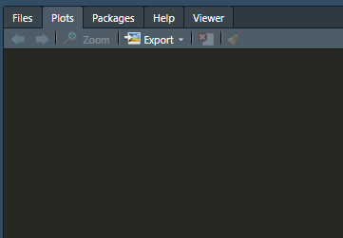

Plots shows any plots made in the current session. In this tab, you can cycle through using the arrow buttons shown above your plot, or export individual plots for later use in your presentations, etc.

### Packages

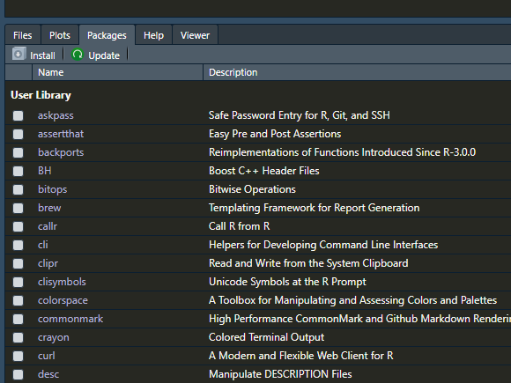

Packages is a list of all installed “packages.” These packages are tools that you can use to expand the base functionality of R. Packages for all sorts of applications exist: packages to do statistical analysis, packages to learn R, packages to generate graphs from data, etc. This is the tab you can use to activate packages or quickly go to their documentation (a la a help page/wiki).

### Help

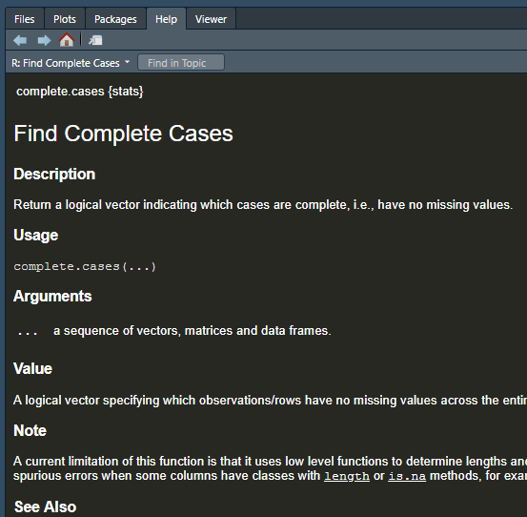

Help is a built-in helper similar to something like a wiki page. This tab can show the required/optional arguments that a function will expect, or what result they will have and what format those results will be in, etc. Sometimes, this documentation will also list use-case examples so that you can see a function in practice.

# How to make use of R as a beginner

## R as a Calculator

The way I gained familiarity with R, even when I didn’t have a script to write or a specific goal: using it as a calculator!

* Scientific calculations like C1V1 = C2V2, finding out how much of a buffer I will need for an experiment or series or expmts… Etc.
* Much easier when you can store values in variables, write small functions to repeat calculations, etc.
* volPerWell * wellsPerPlate * numPlates = total buffer
* Define variables c1, c2, and v2. Now v1 = (c2 * v2) / c1. If you’re doing this calculation multiple times, you can make it into a function and call that function instead of typing out the calculation every time!
* Even if it might be more efficient to use Excel or a calculator, valuable practice in R/RStudio!

## Next Steps

* As you get more comfortable, can move on to making your graphs with R, finding packages to analyze your data in R, etc.
* Use open datasets to do your own analysis or practice/look for inspiration! Lots of open data out there if you just google “open datasets.” Data sets on plants, vehicles, traffic, healthcare, and much more. Can look up example projects to work on, or make up your own!

# Learning Resources

## GOOGLE.

* Any time I want to do something in R (or other languages) and I’m not sure how… I just Google it.
* Usually somebody has had the problem before, or wanted to do the same thing.
* If it’s not my specific use case, usually I can break it into smaller steps that people HAVE asked about before.
* “How to read data from an excel spreadsheet into R”
* “How to make dates in [format] recognized by [package] in R”
* “How to split a full name into two columns in R dataframe”

## YouTube

* Lots of videos out there spanning gamut of use cases/fields
* Practice projects to get more comfortable in R

## Swirl

* “Learn R, in R”
* This is a package in R, meant to run in RStudio
* Meant to teach you about using R, while you’re actually in RStudio
* <https://swirlstats.com/students.html>

## Coursera

* Lots of different R courses with video lectures from renowned universities
* Suggest/promote a “paid” option/subscription that gives verified completion certificates. However, AUDITING COURSES IS FREE. You get the same skills, but no certificate.
* Info on free course auditing: <https://learner.coursera.help/hc/en-us/articles/209818613-Enrollment-options>
* Beginner course on R Programming (Johns Hopkins University): <https://www.coursera.org/learn/r-programming>

## Textbooks

* Many available online for free. Can just google “free ebook for r programming”
* <https://r4ds.had.co.nz/>
* Others may be available in the library, or by interlibrary loan etc.

## Package Documentation

* Most packages have their own documentation. If there’s a function you’re new to or confused about, just look it up in the documentation. There’s usually descriptions of all of the arguments and expected outputs.

## StackExchange/Online Forums/Documentation

* StackExchange is a big resource for people across many topics (Math, Stats, Sciences, Programming…)
* Essentially a Q&A forum with many experts available to answer your questions
* If you are feeling stuck, and your other resources aren’t getting you anywhere, ask a question on StackExchange! (But be sure to read posting rules first)

# Conclusions

* R can be an exceptional tool to scientists at any point in their career
* Don’t be scared off by not being familiar yet!
* Once you get the hang of things, it’s going to be easy to keep building your skills
* Be sure to check out other talks from the R Users Group, and network with other R Users!
* Thank you for your time, and thank you to the R Users Group for helping build the community!

Lots of the installation instructions were based on following link:

<http://derekogle.com/IFAR/supplements/installations/InstallRStudioWin.html>